**BANKING SYSTEM**

**QUESTION # 01:** Model a simple Banking System in Z which will be able to maintain a person’s account in a bank. It will provide the customers to access their account, create new customer’s account and to deposit/ withdraw the cash from their account.

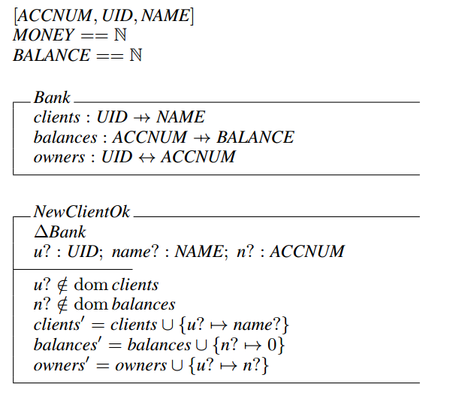

**[*ACCNUM*, *UID*, *NAME*]**

**MONEY ::= N**

**BALANCE ::= N**

┌ **NewClientOk**--------------------------------------------------------------------------------------

ΔBank

u? : UID

name? : NAME

n? : ACCNUM

|

u? ∈ dom clients ∧

n? ∈ dom balances ⇒

clients′ = clients ∪ {u?↦name?} ∧

balances′= balances ∪ {n? ↦ 0} ∧

owners′= owners ∪ {u? ↦ n?}

└----------------------------------------------------------------------------------------

┌ **NewAccountOk ---------------------------------------------------------------------------------**

ΔBank

u? : UID

n? : ACCNUM

|

u? ∈ dom clients∧

n? ∉ dom balances⇒

balances′= balances ∪ {n? ↦ 0}∧

owners′= owners ∪ {u? ↦ n?}

└--------------------------------------------------------------------------------------------------------

┌ **DepositOk**------------------------------------------------------------------------------------------

ΔBank

n? : ACCNUM

m? : MONEY

|

n? ∈ dom balances∧

m? > 0⇒

balances′= balances ⊕ {n? ↦ balances(n?) + m?}

└----------------------------------------------------------------------------------------

┌ **WithdrawOk**---------------------------------------------------------------------------------------

ΔBank

u? : UID

n? : ACCNUM

m? : MONEY

|

u? ↦n? ∈ owners∧

n? ∈ dom balances∧

m? > 0∧

m? < balances (n?) ⇒

balances′= balances ⊕ {n? ↦ balances(n?) − m?}

└----------------------------------------------------------------------------------------

┌ **CheckBalanceOk**---------------------------------------------------------------------------------

ΞBank

u? : UID

n? : ACCNUM

balance! : MONEY

|

u? ↦ n? ∈ owners ∧

n? ∈ dom balances ⇒

balance! = balances(n?)